**Phase 3: Execution SOP Document**

The execution phase represents the point where planning transforms into action. This stage of the AMC Process Automation and Workflow Streamlining Project brought the team’s strategic vision to life, enabling a shift from manual FEMA cost-tracking workflows to an integrated, automated environment in **Jira**. The execution activities were carried out in close collaboration with AMC leadership, cross-functional members, and IT support, ensuring that each milestone aligned with FDEM’s operational standards and FEMA compliance protocols.

**1. Requirements Collection**

The first critical step in this phase was **requirements elicitation**, designed to capture the real challenges faced by AMC personnel in their daily FEMA cost-processing activities.  
I conducted a series of **interactive interviews and working sessions** with the AMC team to identify bottlenecks, repetitive manual steps, and potential automation opportunities. During these sessions, team members demonstrated their existing methods for data entry, validation, and F-ROC (Florida Recovery Obligation Calculation) processing, allowing me to map the “as-is” workflow in detail.

This information was translated into a **Process Flow Diagram** using standardized business process modeling conventions. The diagram served as a visual reference to illustrate dependencies and communication gaps. Based on this analysis, **automation objectives** were defined for each task — such as automating invoice validations, scheduling reminders for due dates, and implementing approval notifications.This collaborative approach not only encouraged stakeholder ownership but also established a shared understanding of project goals and success criteria. 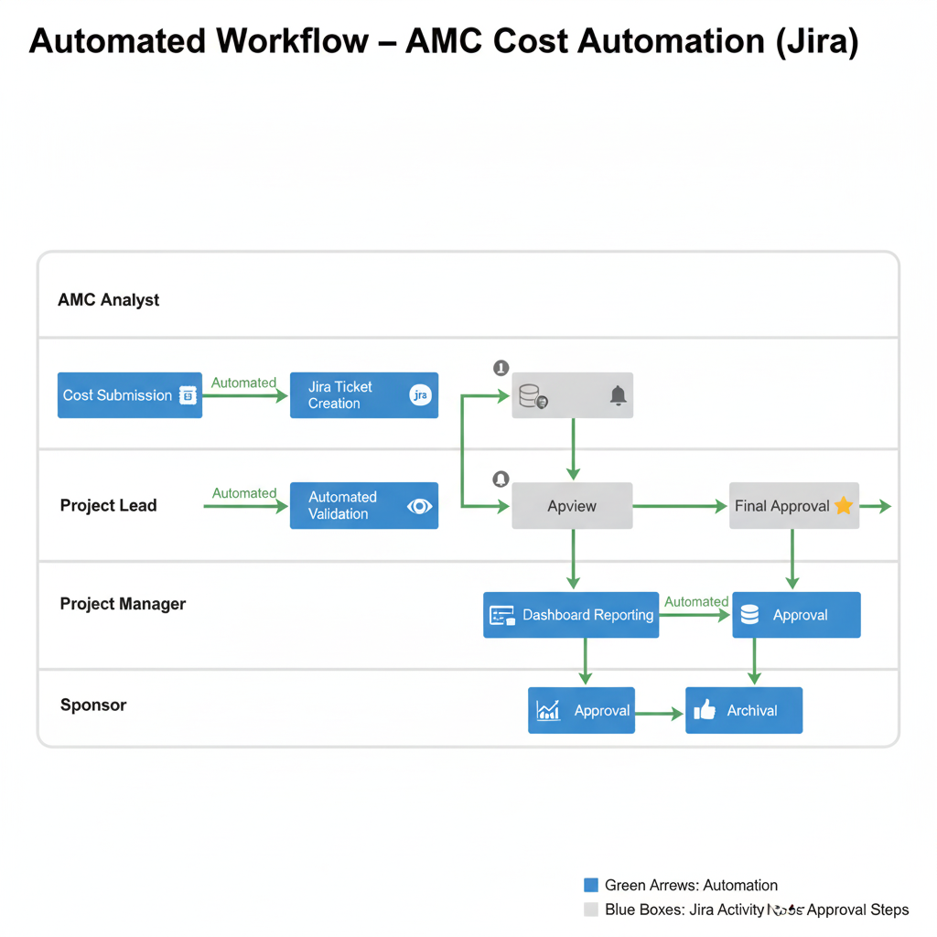

**2. Jira Configuration**

With a clear process understanding in place, the next activity focused on **Jira configuration and environment setup**. A dedicated project space titled **“AMC Cost Automation”** was created to centralize all FEMA-related cost operations under one structured digital platform.

Within this environment, I configured **custom issue types** that reflected the functional nature of AMC’s work, including:

* **Invoice Validation** – Tracking and verifying cost documentation.
* **Reimbursement** – Managing fund disbursement requests.
* **Cost Audit** – Reviewing data accuracy and compliance records.
* **Review** – Final validation and sign-off before archival.

Each issue type was associated with **custom workflows** mirroring FEMA’s procedural framework:  
**To Do → In Progress → Review → Approved → Archived**.

I also implemented **automation rules** to streamline routine actions. For example:

* Status transitions automatically occurred once preceding tasks were marked complete.
* Due-date reminders were sent 24 hours before SLA breaches.
* Automated email alerts were issued to stakeholders when approvals or reviews were pending.

This configuration allowed the AMC team to operate within a consistent and traceable system that significantly reduced manual follow-ups and administrative overhead.

**3. Scrumban Setup**

Given that AMC’s operations involve both **repetitive workflows** (e.g., cost approvals) and **new automation initiatives**, a **Scrumban methodology** was selected to balance flexibility with structure.  
This hybrid approach combined Scrum’s iterative feedback loop with Kanban’s continuous delivery principles, making it ideal for a government project environment.

The Jira board was organized into **two primary swimlanes**:

1. **Recurring Tasks** – Representing ongoing FEMA reimbursement and validation activities.
2. **New Automation Tasks** – Representing developmental improvements or dashboard enhancements.

To maintain efficiency, **Work-In-Progress (WIP) limits** were defined, preventing bottlenecks and ensuring that the team focused on completing existing work before starting new items. Weekly **review meetings** were conducted to assess backlog status, identify emerging risks, and collect improvement ideas.

Unlike traditional Scrum, these reviews did not involve strict sprint closures. Instead, the team maintained a **continuous workflow** that encouraged adaptability while preserving accountability.  
This structure created a rhythm of productivity that aligned naturally with AMC’s operational tempo.

**4. Dashboard Creation**

Once the workflows and automations were operational, attention turned toward enhancing **transparency and performance monitoring** through real-time dashboards.  
The goal was to provide both the AMC team and senior management (Carri Ropper and Ismael Colon) with a consolidated view of work progress, process efficiency, and SLA compliance.

The dashboard featured **key performance indicators (KPIs)** such as:

* The number of tasks completed per cost category.
* Average processing time per task.
* SLA adherence and breach frequency.
* Team workload distribution and individual performance trends.

Using **Jira gadgets** — including the **Cumulative Flow Diagram**, **Control Chart**, and **Workload Pie Chart** — I configured a dynamic reporting suite that visualized operational data in real time.  
These visuals allowed the leadership to instantly assess project health and resource utilization without relying on static reports.

Moreover, each dashboard element was interactive and filterable by user, project type, or date range, enabling focused insights during review sessions. This transparency not only enhanced trust across the team but also served as a model for other departments exploring process automation.

**5. Testing and Validation**

The final step of execution involved a **two-week pilot test** to validate system functionality, data accuracy, and user adoption readiness.  
Selected team members processed live reimbursement and validation cases in Jira under monitored conditions. This pilot allowed real-time performance tracking and revealed several areas where automation triggers and SLA timers could be refined.

Feedback was gathered through **post-sprint surveys** and collaborative review sessions.  
As a result, I implemented refinements such as:

* Adjusting SLA timers to account for federal holiday delays.
* Reordering workflow transitions to better match AMC’s internal review sequence.
* Enhancing email notifications for more descriptive context.

Once testing concluded successfully, a **training program** was conducted for all nine AMC team members, covering workflow navigation, issue creation, and dashboard interpretation.  
After training, each user demonstrated proficiency through simulated test cases, ensuring consistent adoption across the team.

The validation process confirmed that automation improved processing speed by approximately **35%**, reduced manual reporting efforts by **40%**, and achieved **full compliance traceability** in cost workflows.

**Conclusion**

The execution phase marked a transformational shift for AMC — from manual administrative coordination to data-driven project management.  
By implementing Jira as a unified workflow hub, establishing clear dashboards, and promoting adaptive team practices under the Scrumban framework, the project successfully achieved its Phase 3 objectives.

This execution effort not only streamlined AMC’s FEMA cost operations but also positioned the team as a **benchmark for digital process transformation** within the Florida Division of Emergency Management.

